The LORD Almighty
David said to Goliath, “You come to me using the sword, spear and javelin. But I come to you in the name of the Lord All-Powerful, the God of the armies of Israel. You have said bad things about him. Today the Lord will let me defeat you.”
Goliath the Philistine started to attack David. He slowly walked closer and closer toward David, but David ran out to meet Goliath.
David took out a stone from his bag. He put it in his sling and swung the sling. The stone flew from the sling and hit Goliath right between the eyes. The stone sank deep into his head, and Goliath fell to the ground – face down.
So David defeated the Philistine with only a sling and one stone! He hit the Philistine and killed him.

Thought about the reading
This story took place a long time ago, many years before Jesus was born. The Philistines were the enemies of the people of Israel. Goliath was their champion. He was a giant and a great and powerful soldier. Everyone was frightened of him. None of the Israelite soldiers wanted to fight him.
David was only a boy. He looked after his father’s sheep. He was not a soldier, but he knew that God would help him defeat Goliath. He agreed to fight him, and he defeated him!
Sometimes we have big problems in our lives, and we feel weak and helpless. But God will help us, just as he helped David. Our God is the Almighty God who can do anything. Nothing is too difficult for God!

Prayer
Father God, thank you that you are the Almighty God. Thank you that nothing is too difficult for you.
Please help me to trust you when there are big difficulties in my life. Help me to remember that with you, I can overcome those difficulties, just like David defeated Goliath.
Amen

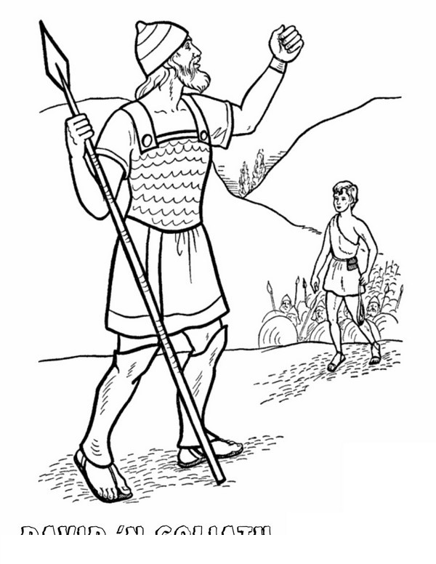

Cambridge Causeway

Spring 2022
Bible Study notes

Names of God
5. The LORD Almighty
By Chrissy Cole

